**BACK GROUND INFORMATION**

Hello this project mainly focused on adding a student dashboard feature to help the students for their interactions on the Accredian website or in the App. We are doing this project to ease the communication between the students in their own learning platform .so that will eradicate the existence and the use of WhatsApp and other social media platforms

**PROBLEM STATEMENTS**

“Hello I am Anto Benny working as a product manager at Accredian am trying to build a platform for students for communicating and interacting with in themselves  But There are already other applications are there but for the students sometimes get it might feel those apps are too hard to use due to the interface and error prone and time consuming.”

**GOAL**

We are aiming to develop an easy communication platform and that would help to reduce the students issues. And a user friendly interface along with the new additional features to hook the users for a while .insted of depending any other application like WhatsApp or telegram or Instagram they can use all the entire features on this application. And make attractive interface and daily quest and exiting offers for attracting more users into it

**HYPOTHESIS & FEATURE DESCRIPTION**

"Hypothesis: Implementing an chat feature in the application will increase user engagement and satisfaction, leading to longer session durations and higher retention rates. This hypothesis is based on the assumption that users will find the new chat helpful for accessing support, seeking information, and interacting with the application's features more seamlessly."

This feature is building using react native. And this will build a great platform and perform excellent as well

* This feature has different functionalities it's easy to create groups over there based upon their batch no need to save their personal number like in the WhatsApp. based upon on batch number they can create groups and invite other candidates
* Creative interface along with engaging questions, and topic discussions opportunity and winning exciting prizes
* Adjustable chat theme color for personal chat, and in the group chat attachments option without any specific criteria and it would load any amount of data

Editing after sending is possible

* Inter personal communication will happen only both party agree
* Weekly winner contest within in the group itself
* Free study material access
* Image transition into words
* AI Correction of words and spoken English practice as well using chat bot and AI Voice processing bots
* Topic related news article and glimpse of technology content
* Project collaborations
* Virtual study rooms this would foster the community
* Event calendar’s such as students get updated about all the activities were happening in the collage.

These are the features we planned to include in the feature.

**VISION NARRATIVE**

We were on a mission to create an app that would erase all the problems and barriers faced by students on existing social media platforms like WhatsApp and Telegram.

As we brainstormed, a vision began to take shape. They envisioned an app tailored specifically for students, a one-stop solution that would eliminate the need for multiple external applications and communication networks. With this app, students could seamlessly connect, collaborate, and communicate without the distractions and limitations of traditional platforms.

In our vision, they **saw students effortlessly sharing lecture notes, organizing study groups, and coordinating project collaborations. No longer would they have to navigate through**

**endless group chats or sift through cluttered message threads.** This app would streamline communication, making it easier for students to stay focused and productive.

One of the **key use cases we envisioned was the ability to create virtual study rooms, where students could gather online to study together, share resources, and ask questions in real-time. This would** not only foster a sense of community but also enhance collaborative learning opportunities.

Another use case that **emerged was the integration of academic resources directly into the app. From textbooks and research papers to exam schedules and study guides**, students would have access to a wealth of educational materials right at their fingertips. This would help eliminate the need to juggle multiple apps and websites, saving students valuable time and energy.

Furthermore, **we imagined features such as event calendars, where students could stay updated on campus activities, academic deadlines, and social event**s. Whether it was a club meeting, a guest lecture, or a campus-wide festival, students would never miss out on important events again.

As our vision continued to unfold, we were filled with excitement and determination. We knew that building this feature would only

simplify student life but also empower students to take control of their education and connect with their peers in meaningful ways. With their combined skills and passion, we are ready to embark on this journey and create a game-changing platform for students everywhere. And more over building this kind of **application would lead to company success and it will attract new investors**

**KEY TRADE OFFS & DECISIONS**

**Which one should prioritize?**

One of the major decision would appear for the prioritization of the features because we already mentioned several features for that application and including each one of them in the process individually it’s a compete task

**User interface decision**

Designing a user-friendly interface would be crucial to the app's success. The team would have to make decisions about the layout, navigation, and overall aesthetics of the app

**Privacy and security.**

Ensuring the privacy and security of user data would be a top priority. The team would need to make decisions about how to protect user information, prevent unauthorized access, and mitigate the risk of data breaches

**Cost calculation and inviting investments**

This part would require a great time and effort cost calculation for the app will define a great part in the production because it only define how the app would look like .if do we want to make it better we required a lot money .and attracting investors also a better idea to get a huge capital for the development.

**scalability and performance**

As the app grows in popularity, it would need to be able to handle increasing numbers of users and data traffic. The team would need to make decisions about the app's architecture, infrastructure, and technology stack to ensure scalability and optimal performance

* And our team had already made some decision about how we should launch the product we can multiple ways to enter into the market and some of the ways are

**Integration with existing app or merger or Acquisitions**

Instead of building a standalone app, the team could have explored partnerships or integrations with existing social media platforms or educational tools

**Open source development**

Including all the developers and using there collaborations for building the website using hands on project development

**Targeted Features vs. Comprehensive Platform**

Instead of aiming to create a comprehensive student communication platform, the team could have focused on building specific features or tools to address particular pain points faced by students.

**CONCEPT MOCKS**

For understanding the concept we are now selecting a web sourced picture of some other app

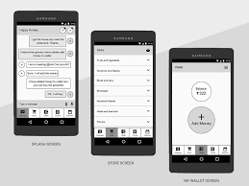

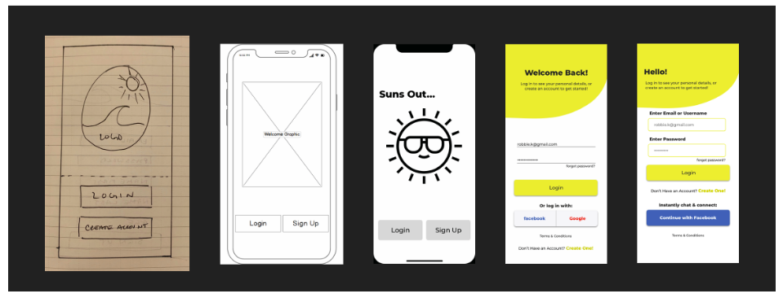

This is how we create wireframe and here we shows the demo of that

**RISKS & MITIGATIONS**

Obviously we can expect risks in the pattern of development and in all the process some of the risks are mentioned below

**Security risks**

Risk of data breaches or privacy violations, especially considering the sensitive nature of student information.

Mitigation:

Implement robust data encryption and security measures to protect user data

Regularly conduct security audits and penetration testing to identify and address vulnerabilities.

Create or tie up with any good cyber security wings or a company

**Cost planning risk**

Un expected costs would have appeared so prior to that estimate the appropriate cost. and understand which element of development would consist this amount of cost get a prior idea about it

**Technical Challenges**

Risk of encountering technical difficulties or limitations during app development, such as compatibility issues with different devices or operating systems.

Mitigation:

Conduct thorough research and feasibility studies before starting development to identify potential technical challenges.

Prototype and test the app on various devices and platforms to ensure compatibility.

Employ experienced developers and technical experts to address any unforeseen technical issues promptly.

**Competition**

Risk of facing competition from existing social media platforms or similar student-focused apps.

Mitigation:

Differentiate the app by focusing on unique features or benefits that set it apart from competitors.

Continuously monitor the competitive landscape and adapt the app's features and marketing strategy accordingly.

**APPENDIX: RESEARCH**

<https://www.lucidchart.com/pages/wireframe>

<https://uxplanet.org/ux-case-study-make-whatsapp-a-little-more-comfortable-c794b1de0ee4>

<http://bth.diva-portal.org/smash/get/diva2:1707558/FULLTEXT02.pdf>